**Login**

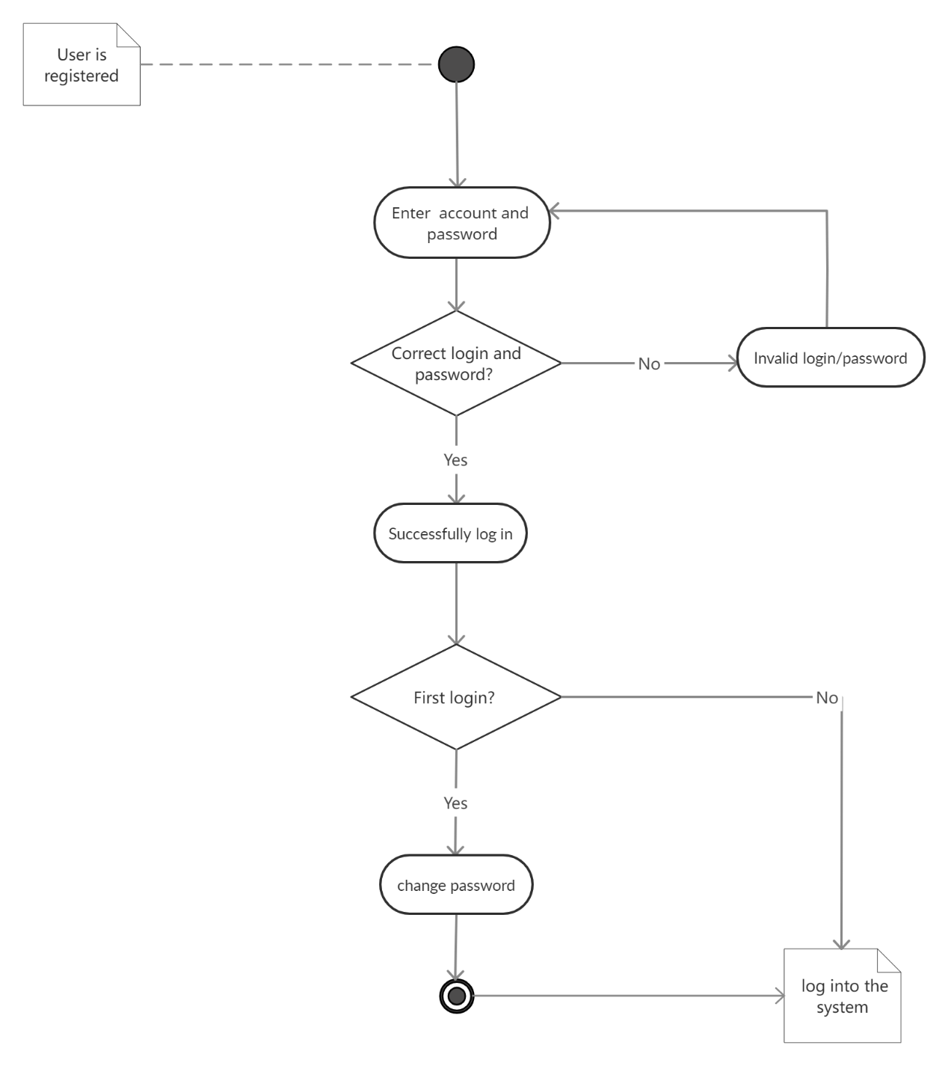

**User interface**

Page “Login” has a form and a button to submit user information to log, and there is a “register” button to reach the “Register” page to create a new account.

(need screenshots?)

**Acceptance Criteria**

Users can only submit a form by filling in all the required fields.

If a user submits incorrect password over three times, this account will be frozen for a while.

**Change Password**

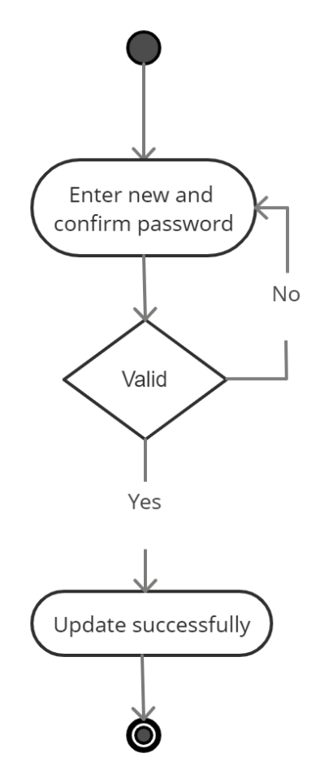

**User interface**

Page “Change Password” has a form and a button to submit password information to the website system.

(need screenshots?)

**Acceptance Criteria**

The new password must be more than 8 characters, contain at least one uppercase letter, one lower case letter, and at least one number.

The new password cannot be the same as the old password.

The new password must be the same as the confirm password.